SEPARATION ANXIETY
Step by Step

Separation anxiety is the fear of being alone. Fear of being left alone and feeling abandoned are the worst things that can happen to the pack animal, the dog.

No matter what breed, or age, dogs can learn to be alone for certain periods but it takes time and patience to do this.

As dogs are social animals who need social interaction and company, they simply want to be with us, and so it is always best to leave them alone for the least amount of time possible. It is not always to do this of course with our busy lives, and it is necessary to leave them from time to time. This should be kept to a maximum of 4-5 hours occasionally. Would you leave a 2-3 year0old child at home all day? Is can also be depressing for old people to be left alone all day? We shouldn’t leave puppies either.

- Take away the possibility for the dog to be afraid
- Get company
- Take the dog with you
- Doggy Day Care
- Dog Sitter – family members, retired people, paid sitter
- Stay at home with the dog
- Disconnect the doorbell if this is an issue
- Make sure the dog has water
- Ensure the dog has been fed

- Get the stress levels down (see brochure on Stress on how to do this). Let the dog feel safe. (remember that being alone is also a stressor).

Exercise increases production of the stress hormone adrenaline. DO NOT take the dog for a lots of exercise or ball throwing before leaving it alone as the adrenaline will already be in a high state. Leaving the dog will increase it further. Leave the dog in a relaxed calm state. Come back from a slow walk in a relaxed and calm manner or do a treat search instead - see brochure “The Importance of Smell”.

- Get a Health Check
- Pain can be a reason for fear
- Hypothyroidism can cause anxiety (get a blood test done if fear continues)
- A small physical thing such as fleas or ear mites can cause stress
- Stress can build up over time, then boom! Read my “Stress” brochure

- Are there any other stressors?
- Construction work outside
- People coming and out of cars outside
- Being in a crate or small enclosed room will cause huge stress
- Flight path
- Constant noise from electrical items in the house

Find the reason for the fear and change it
Separation anxiety = fear
A dog showing SA is really suffering

Once you have addressed the above and reduced ALL possible stressors do the following: step by step training. This takes TIME and you need to plan it.

- Teach the dog a visual hand signal. A gentle, calm, slow signal using the palm of your hand facing towards the dog (not like a firm “sit, stand signal). Use this hand signal EVERY time you get up from your chair, EVERY time you leave the room, in all situations when you get up and leave or move to show the dog that all is OK.

SAY NOTHING. No words, just the hand signal. Use it when you are doing something, and then sit down again so the dog knows you are coming back - each time you go and make a coffee or go to use the toilet. Practise many times getting up from the sofa – hand signal – back down again until the dog is not stressed with you doing this. The dog will soon learn that this hand signal means “just relax, everything is OK”.

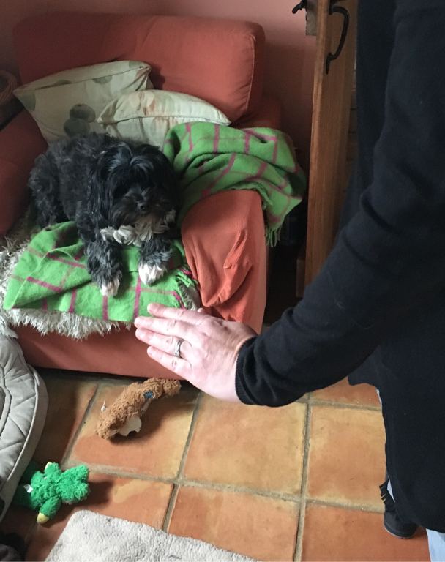

- Practise the hand signal every time you get up from your seat, leave or move.

While training, do NOT leave the dog alone other than the “training”. This needs to be gradual so that the dog doesn’t have time to become fearful, anxious or stressed.

- When the dog is comfortable with this, you can start by going from one room to another, such as living room to hall. When you leave the room and come back in fast. Let the dog hear you and be able to see you so that it knows where you are.

Go out, close the door for literally a few seconds and come in again STRAIGHT AWAY, so the dog knows you are coming back each time. Practise this. SAY NOTHING. Just use the hand signal and go.

- Vary the length of times you do this increasing to 20 seconds, 30 seconds, 1 minute etc. over a period of time. Only increase the time if the dog is comfortable and not stressed. Practise it 2, 3, 4 times a day. No fuss leaving. No fuss coming back. Just calmly say “hello dog”.

- When the dog is comfortable with this, you can progress to coming in and out of the front door, but start with just seconds again, and build up the time. DO NOT PROGRESS TOO QUICKLY in these steps.

All dogs can learn to to be alone if they feel comfortable
They care more about company than they do fresh air
It is totally inappropriate to punish a dog for fear of being alone
Punishing fear will make a dog more afraid
Obedience will not help. Fear is Fear
Confinement in a crate will not help. Confinement = fear
Only gradually teaching a dog to COPE will help


Elaine Stavert
Canine Behaviour Therapist
01525 242141 or elaine@animaltherapyworks.co.uk

